CS 255 System Design Document Template

UML Diagrams

UML Use Case Diagram
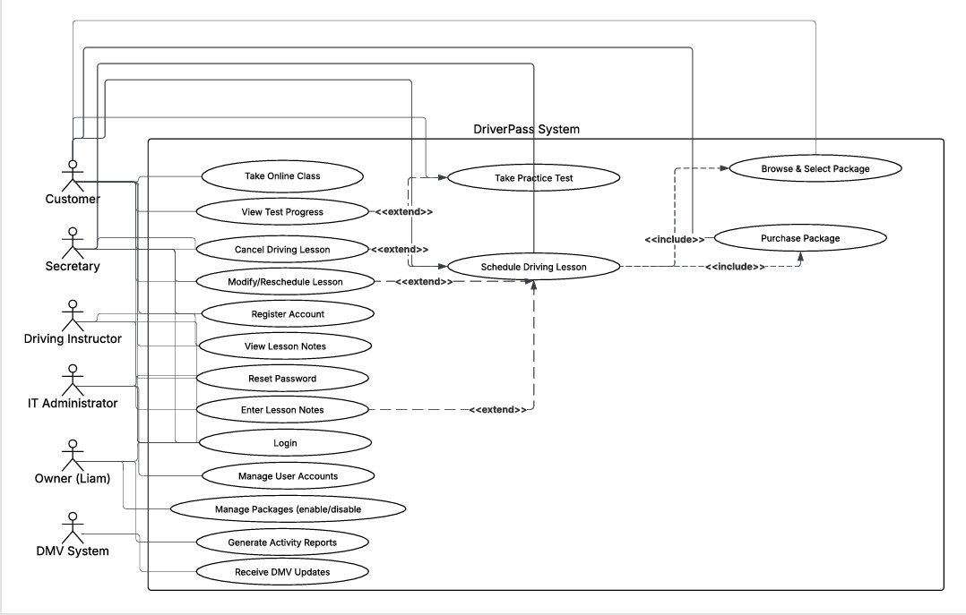

UML Activity Diagrams
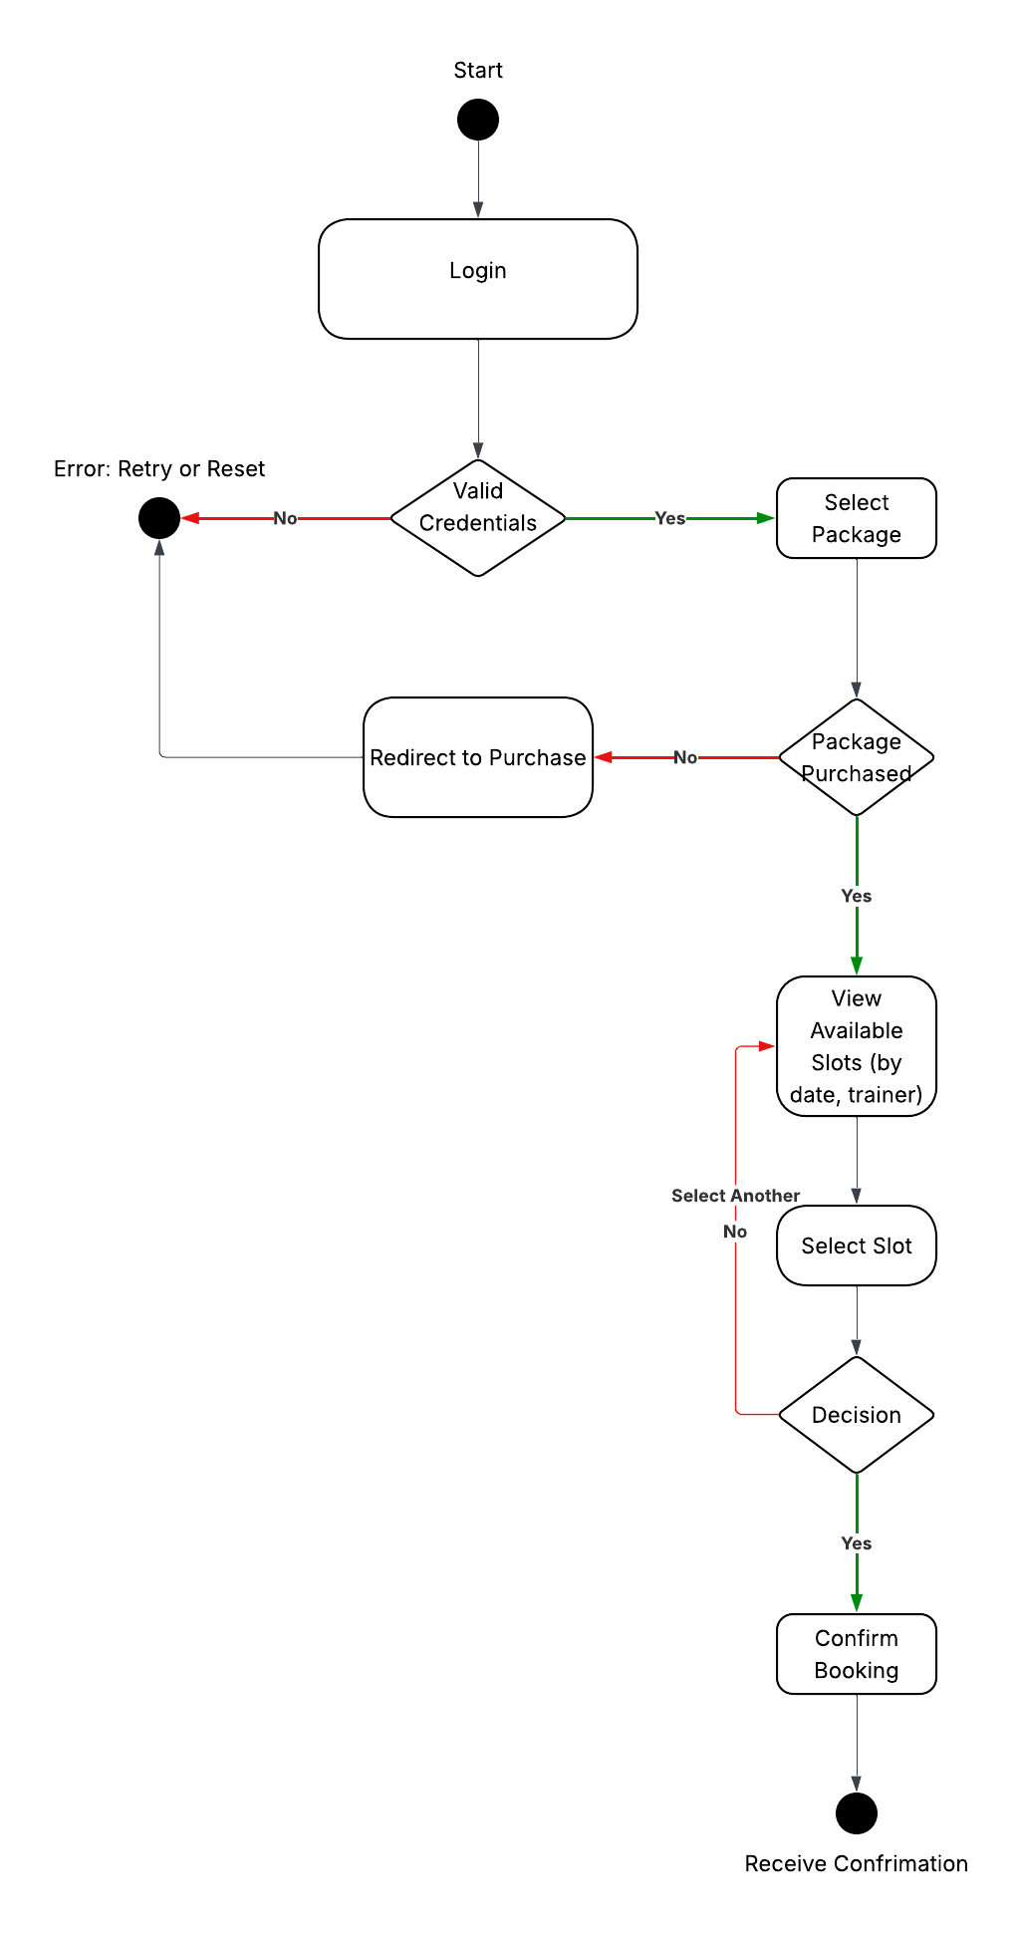
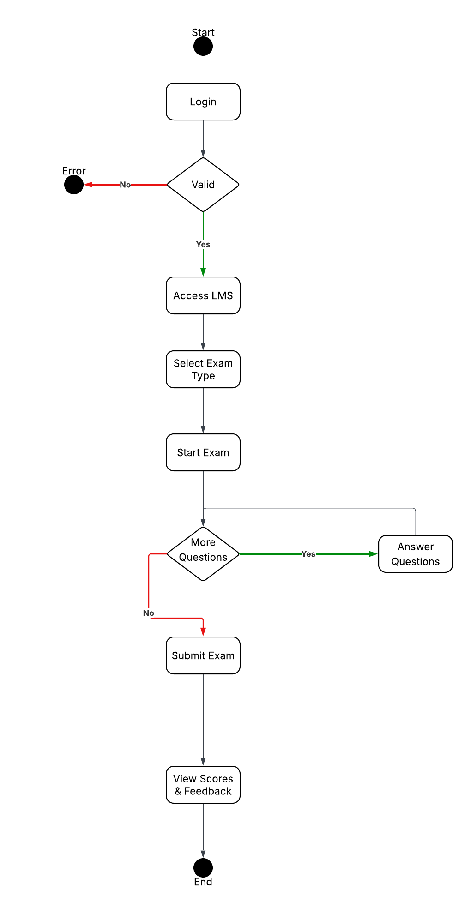

UML Sequence Diagram
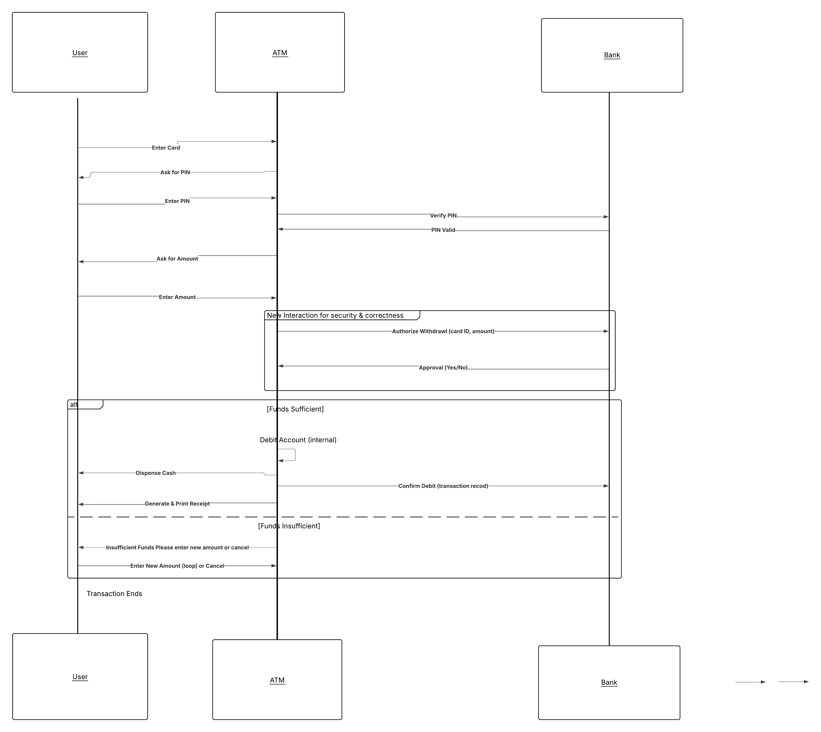

UML Class Diagram
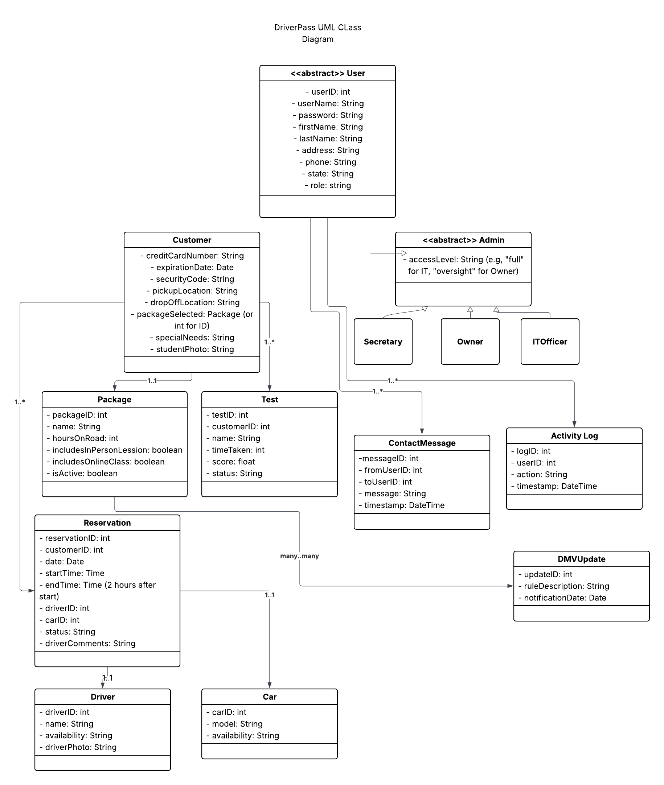

Technical Requirements
Hardware Requirements
- Client Side: Standard personal computers or mobile devices with at least 4GB RAM, modern processor (e.g., Intel i5 or equivalent), and internet connectivity. Supports desktops, laptops, tablets, and smartphones for web access.
- Server Side: Cloud-based servers (e.g., AWS or Azure) with redundant hardware to avoid single points of failure, including multiple processors, at least 16GB RAM per instance, and scalable storage (SSD-based, minimum 1TB initial).
Software Requirements
- Operating Systems: Client - Windows 10+, macOS 11+, iOS 14+, Android 10+. Server - Linux-based (e.g., Ubuntu) for hosting.
- Web Browser: Latest versions of Chrome, Firefox, Safari, Edge for the web interface.
- Database: Relational database like MySQL or PostgreSQL for storing user data, appointments, and exam content.
- Programming Languages/Tools: Backend - Java or Python with frameworks like Spring or Django. Frontend - HTML5, CSS3, JavaScript with React or Angular. Integration with DMV APIs for updates.
- Security Software: SSL/TLS for encryption, firewall, intrusion detection systems.
Tools and Infrastructure
- Development Tools: Lucidchart for UML, Git for version control, Jira for project management.
- Infrastructure: Cloud hosting for scalability, with auto-scaling groups. Offsite backups for data recovery. API gateways for DMV integration.
- Security: Two-factor authentication (2FA), password hashing (e.g., bcrypt), role-based access control (RBAC), regular security audits. Compliance with data protection standards like GDPR or CCPA for handling personal and payment information.
- Performance: System should handle up to 1000 concurrent users, with response times under 2 seconds. Load balancing and caching (e.g., Redis) for efficiency.

